Estadística para el análisis de Datos.

Nombre:

“PROBLEMS FOR SECTION 3-2

Considering the Figure 3-3, please answer the following questions:

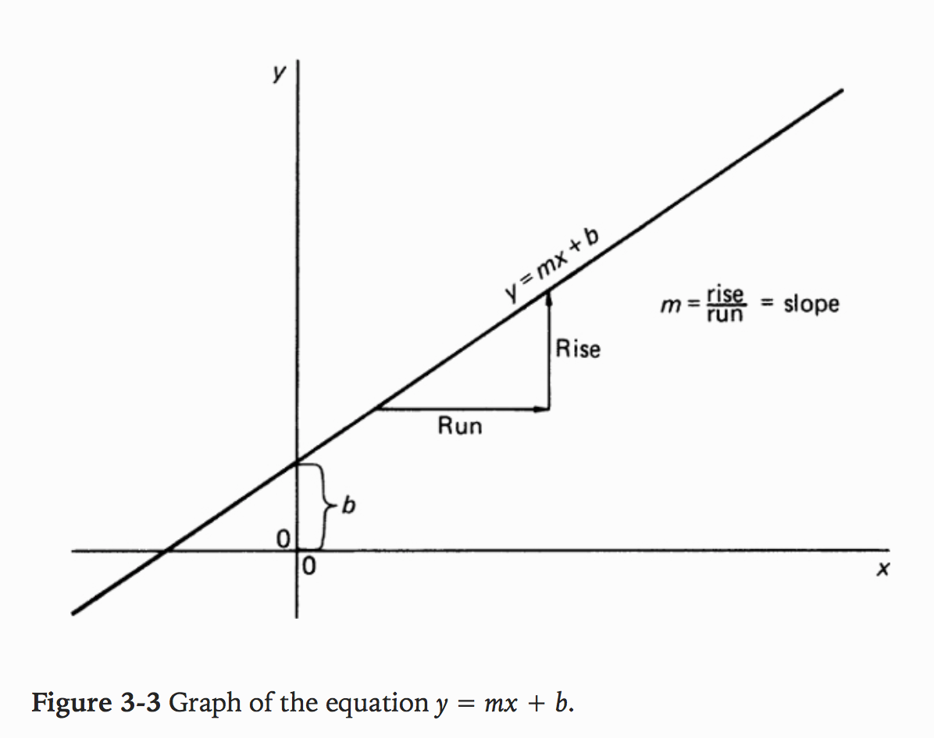

1. Which of the following formulas define y as a linear function of x (m and b are constants)?

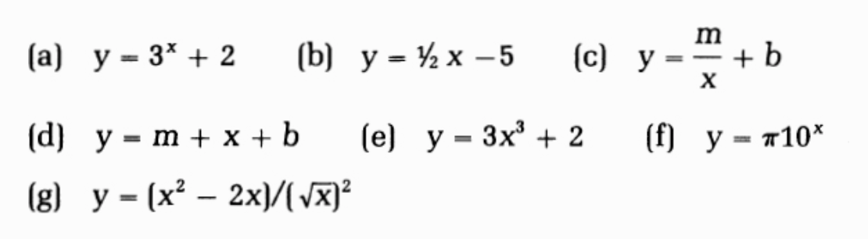

2. A straight line passes through the points (3, 5) and (4, 7). Use these points to find a rise and corresponding run, the slope of the line, and the y intercept b.”

“For convenience in distinguishing the dependent variable (usually called y) in the following problems, we shall use the capital letters B, C, D, E and F instead of y.

In each of these problems a precise relation exists between two variables. Find the relation. Transform the x variable in each problem to get the points on a straight line.

3. Given these data:

|  |  |  |  |  |  |  |  |
| --- | --- | --- | --- | --- | --- | --- | --- |
| B | 3 | 6 | 11 | 18 | 27 | 38 | 51 |
| x | 1 | 2 | 3 | 4 | 5 | 6 | 7 |

Find a way to plot the relation between B and x to get the points on a straight line.

4. Given these data:

|  |  |  |  |  |  |  |  |
| --- | --- | --- | --- | --- | --- | --- | --- |
| C | 5 | 11 | 21 | 35 | 53 | 75 | 101 |
| x | 1 | 2 | 3 | 4 | 5 | 6 | 7 |

Find a way to plot the relation between C and x to get the points on a straight line.

5. Given these data:

|  |  |  |  |  |  |  |
| --- | --- | --- | --- | --- | --- | --- |
| D | 1024 | 512 | 256 | 128 | 64 | 32 |
| x | 1 | 2 | 3 | 4 | 5 | 6 |

Find a way to plot the relation between D and x so that the points fall on a straight line.

6. Given these data:

|  |  |  |  |  |  |
| --- | --- | --- | --- | --- | --- |
| E | 120 | 60 | 40 | 30 | 24 |
| x | 1 | 2 | 3 | 4 | 5 |

Find a way to plot the relation between E and x so that the points fall on a straight line.

7. Find the slope when F is plotted against x2 for the following data, and then give the formula relating F and x2.

|  |  |  |  |  |
| --- | --- | --- | --- | --- |
| F | 0.283 | 0.785 | 1.54 | 2.54 |
| x | 0.3 | 0.5 | 0.7 | 0.9 |

For each of the following equations, give a transformation that will put the equation into the form y = mx + b (not necessarily using[…]”

8. y = 4πx2

9. y = 5x3 – 10

10. Y=3/x1/2

11. y = 5(10x)

Frederick Mosteller. “Beginning Statistics with Data Analysis.” iBooks.